YMCA and Associated Entities Procedure – OHS039-G (PR) Incident Management Procedure
Procedure Number | Date Approved | Date Last Amended | Status
OHS039 | 5/03/2019 | 23/11/2018 | Current

- PURPOSE
The Incident Management Procedure outlines the process for how we respond, classify, communicate, investigate and learn from incidents at the YMCA. This includes incidents across all areas of the business.
Our primary focus is on the prevention of incidents and injuries, however when incidents, injuries or near misses do occur we have an opportunity to identify the cause and implement corrective actions to prevent reoccurrence. This procedure outlines the steps to be taken following an incident at the YMCA.
- SCOPE
This Procedure applies to The Young Men’s Christian Association of Victorian Inc. and associated entities including Kingswim and The Victorian YMCA Youth and Community Services Inc. For the purposes of this document, we refer to these entities as the YMCA.
The scope of this Procedure applies to all Board members, Sub Committee members, staff and volunteers.

- PROCEDURE – YMCA VICTORIA REQUIREMENTS
The procedural steps to ensure effective incident management are illustrated below. These actions are to be taken in line with the Incident Management Process Action Lanes (Supporting Document 1).
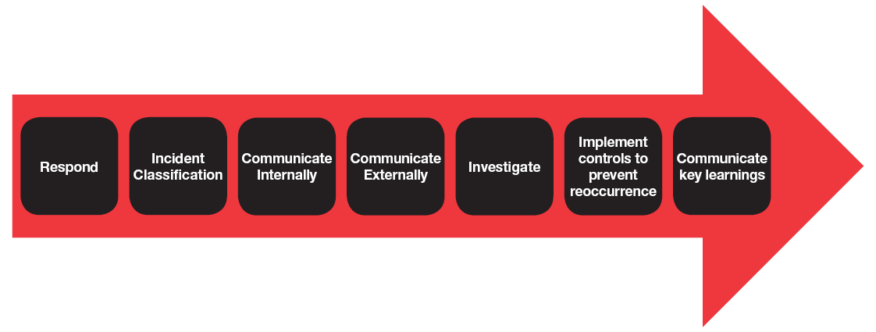

  - Respond
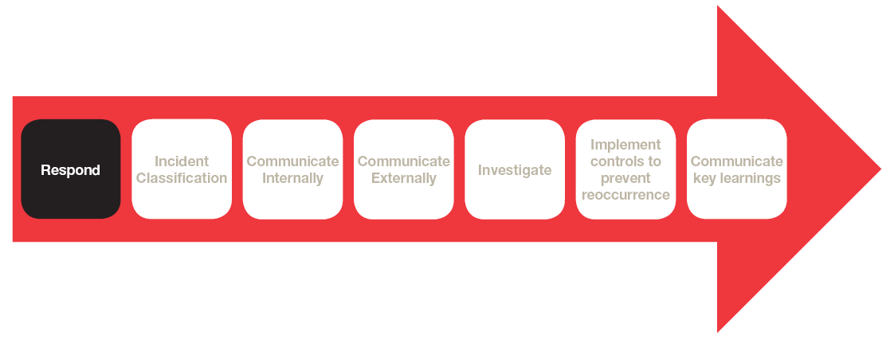
- Call for help
Ask for help from colleagues or management on site to assist with incident response. Follow the Incident Management Process.
Immediately call 000 if the assistance of emergency services (police, fire or ambulance) is required.
- Make the area safe for everyone
Manage immediate risks to ensure the safety of everybody (i.e. turn off the power or remove trip hazards etc.), whilst attending to any injured or affected person(s).
- Protect and Secure any property/infrastructure
If an electronic equipment incident or privacy breaches from an IT perspective is suspected, report the incident to the IT Helpdesk team immediately as timing is imperative to protect data.
- Preserve the scene
Preserve the scene where a Critical or notifiable incident to an external authority or regulator has occurred. Management must ensure that the incident location or relating equipment is not disturbed. This includes where reasonably practicable isolation of incident area, leaving plant and equipment (including IT equipment) in place as it is and retaining any video or photo evidence of the incident (including any phone video or CCTV footage).
Please note: for photography for Safeguarding Children & Young People incidents refer to the Safeguarding Children and Young People Procedure.
- Obtain Legal Advice where required
Before collecting and recording information relating to an incident or near miss, assess the situation to determine the possibility or concern that could potentially give rise to a claim or legal proceedings being commenced against the YMCA, such as Regulatory (E.g. Worksafe, EPA, CCYP, OAIC, DHHS and DET) through an incident investigation, or by a patron.
If yes, the Area Manager must contact the relevant General Manager (or Development Manager in Recreation Sector) who with relevant senior management, will engage legal representation to seek guidance and advice. If Legal Professional Privilege (LPP) is applied certain processes must be followed in relation to information management and communication.
- Follow Emergency Management Plan
Each site has an Emergency Management Plan which is to be enacted as appropriate in the event of an emergency.
- Provide Treatment
Provide treatment for medical incidents and support for all People and Culture, Reputational, IT, Financial incidents.
Where there has been an injury, utilise the relevant first aid forms depending on severity of the injury.
  - First Aid Report Form – Minor Injury
  - First Aid Report Form – Major/Critical Injury
Where the injured party is an employee, after initial attention by a qualified first aider, follow the Injury Management Procedure.
Ensure the safety and wellbeing of everyone impacted including bystanders or family members of the injured person(s). The Employee Assistance Program (EAP) can be utilised for either one-on-one counselling sessions (for staff, volunteers or patrons) or for a group incident debrief (for staff and volunteers).
The EAP contact details are: LifeWorks by Morneau Shepell 1300 361 008.
3.1.1 Presentation of an External Authority or Regulator on site
Where the Department of Health and Human Services (DHHS) child protective services attend a site to collect a child and, they are not the authorised contact for that child, it is imperative that identification is obtained, recorded and verified with DHHS child protection.
A phone call is to be immediately made to DHHS child protection to confirm authority for that individual to remove the child and for the facility transfer duty of care to the authorised officer. A phone call is also to be made immediately to your Area Manager before the child is released into the care of the authorised officer. Refer to the External Authority Notification table on how to contact DHHS child protection.

  - Incident Classification

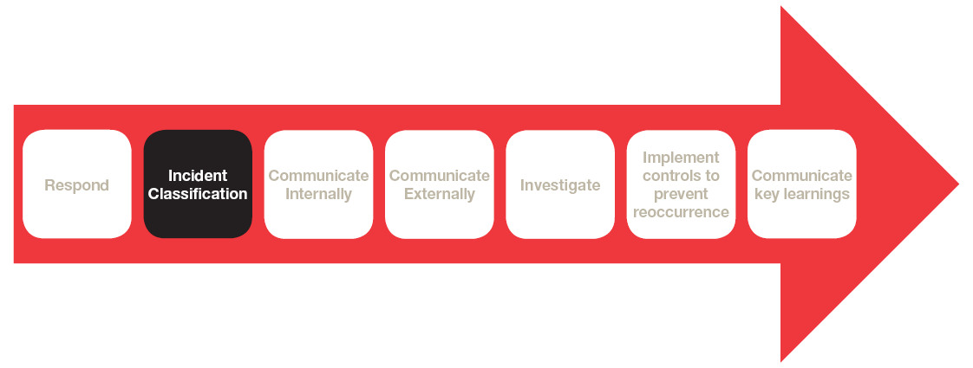
All incidents are classified as either Critical, Major or Minor based on the risk consequence level. These three classifications determine the actual or potential severity of impact each incident has to the YMCA.
These classifications are defined in the following table.

When determining the classification, it is important to consider not only the actual but also the potential consequence and impact of an incident:

• Is it an incident or a near miss?
• What happened to cause the incident or near miss?
• What was the actual impact at the time of the incident or near miss?
• What is the potential impact or consequence of the incident or near miss?

TABLE 1 – YMCA and associated entities - Incident Classification Table
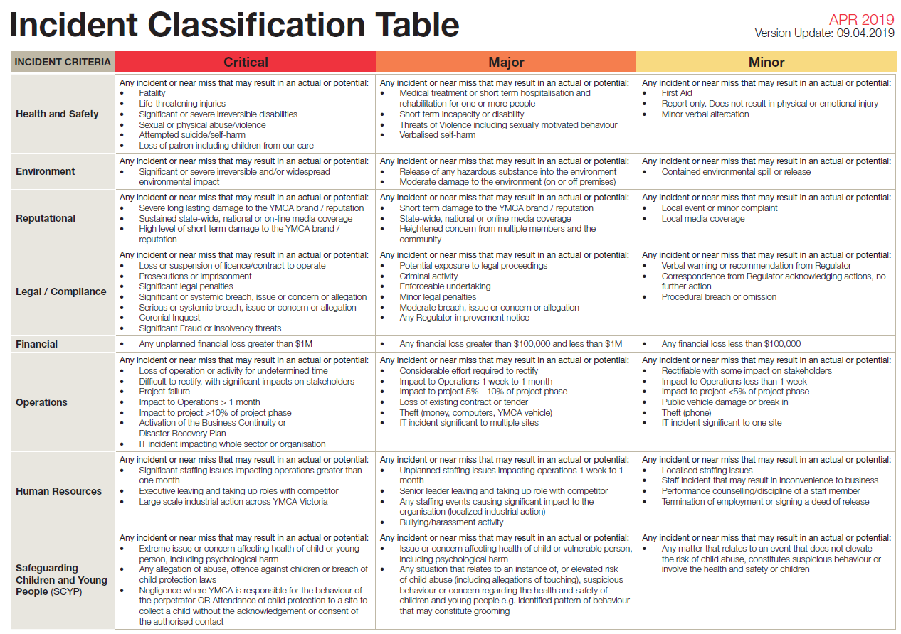
  - Communicate Internally
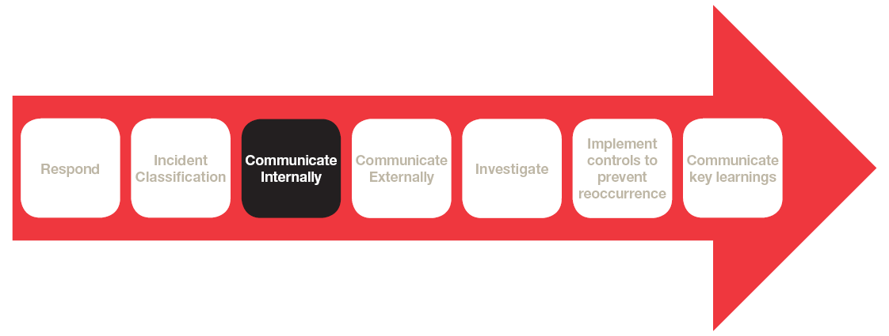
All staff must immediately report incidents and near misses to their respective supervisor as outlined in the Incident Management Process Action Lanes. Supervisors will classify the incident in line with the definitions of Critical, Major and Minor.
All incidents must be recorded in INX (the YMCA’s Online Incident Reporting System) as outlined below. Where supporting documentation has been generated/provided this must be attached to the INX record. This can include (but is not limited to):
• First Aid reports
• Details of any medical treatment including certificates
• Interview Record
• Any complaints received
• Photos of the incident scene or equipment involved (for photography for Safeguarding Children and Young People incidents please refer to the Safeguarding Children and Young People Procedure.)
• Legal documentation
• Copies of any correspondence with external parties/regulators
• A Key Event list for Critical Incidents and HR Major Incidents.
Prior to a critical incident or an incident under Legal Professional Privilege being submitted into INX, the relevant people to be involved in the incident response and investigation should be identified. The incident can then be submitted into INX, but the ‘Restricted’ tick box should be selected prior to pressing ‘Submit’. The ‘Restricted’ function will lock down the individual incident from everyone who would normally have access and email notifications will not be sent. The relevant people to be involved can then be selected from a drop-down list and only these people will then have access to this incident. Additional people can be added and existing people can be removed during the life of the incident.

3.3.1 Communicating and Recording Critical Incidents Internally
In the event of a Critical Incident, the Site Manager must immediately escalate the incident to their Area Manager.
The Area Manager will immediately notify;
- Their respective General Manager or Development Manager to seek legal advice.
- The relevant Shared Services department (Business Systems, Communications, Finance, People and Culture or RSEQ)
The General Manager or Development Manager will notify;
- Their respective Executive Officer who will then notify:
  - The Chief Corporate Services Officer
  - The Chief Operating Officer
- The Chief Operating Officer will then notify:
  - The Chief Executive Officer
- The Chief Executive Officer with then notify:
  - YMCA Victoria Board Members
  - YMCA Australia
Develop Critical Incident Team (CIT)
The Critical Incident Team (CIT) will be engaged immediately following a Critical Incident occurring.
The operational General Manager (or Development Manager in Recreation Sector) will become the Critical Incident Team Lead and will be responsible for:
- Setting up the Critical Incident Team (CIT) and following the Critical Incident Team Checklist.
- Identifying any conflict of interest within the CIT, and determining appropriate actions.
- As part of the CIT Checklist, ensuring a Key Event List is maintained.
- Engaging the relevant Shared Services Managers for specialised advice and support.
- Data collation/storage (including CIT agenda and minutes) and confidential upkeep of information of Critical Incidents on the Critical Incident Page on YNet.
- Arranging support or a Critical Incident debrief with all employees and volunteers impacted by the incident (including any CIT members) with the engagement of the EAP.

The CIT will direct and facilitate the management of the incident. The role of the CIT is to ensure relevant people are engaged and informed, staff are being appropriately supported, and that immediate controls are in place. The CIT will oversee the internal and external communications, with the support of the Communication Team. The lead investigator will be allocated by the CIT, on the basis of availability and specialty skill set. The CIT will consist of relevant people across multiple areas of the business to ensure a broad range of expertise is utilised.
Where support is required to manage day to day workload for certain CIT members, their direct manager will arrange suitable resourcing to ensure the CIT member is able to fulfil their obligations as a CIT member. In the event that a member of the CIT is on leave or away, it is their responsibility as a CIT member to delegate responsibilities to an alternative staff member. Part of this process is ensuring that the delegate has read and understands the Incident Management Procedure, related documents and has the capacity and capability to carry out any duties required of them.
Extraordinary Incidents/Crisis Management
There are times when a Critical Incident is extraordinary in nature; for example, the incident may involve a Director, CEO or Executive Officer as party to the incident, or an extraordinary organisation event may occur i.e. major fraud, multiple fatalities etc. At this time, an external probity advisor may be engaged by the Board and their role is to observe, review and report on the incident as directed by the YMCA Victoria Board.
Critical Incidents should be recorded into INX immediately post legal advice.
With all Critical Incidents that are not the subject of LPP an incident investigation is required to determine root cause(s) and corrective actions implemented to prevent reoccurrence. Details of the evidence gathered to investigate, must be attached to the online incident report (INX). Critical Incidents also require the following to be completed by the Critical Incident Team Lead to ensure accurate recording;
• Development of a YNet Critical Incident page which holds all documentation, meetings and actions.
• Update of the Governance Legal Log if legal advice is sought.
• Update YNet Critical Incident Log.
• Critical Incident Status report provided to YMCA and associated entities CEO and Board outlining the status of the incident (report required immediately post initial CIT meeting).
• In respect of all Critical Incidents that are subject to LPP, any such investigation will be subject to the advice and recommendations provided by the relevant legal advisor.

3.3.2 Communicating and Recording Major Incidents Internally
Major Incidents to be escalated by Site Manager to Area Manager
In the event of a Major Incident or Near Miss, the site manager must immediately escalate the incident to their Area Manager. The Area Manager will immediately notify;
- Any Major Incident to the relevant Shared Services department (Business Systems, Communications, Finance, People and Culture or RSEQ)

Major incidents should be recorded into INX within 24 hours (post legal advice - if required). Details of the evidence gathered to investigate, must be attached to the online incident report (INX).

3.3.3 Communicating and Recording Minor Incidents Internally
Minor Incidents to be escalated by Supervisor to Site Manager
Minor incidents must be reported to the supervisor using the relevant form, before the end of shift and recorded into INX within three business days.

  - Communicate Externally
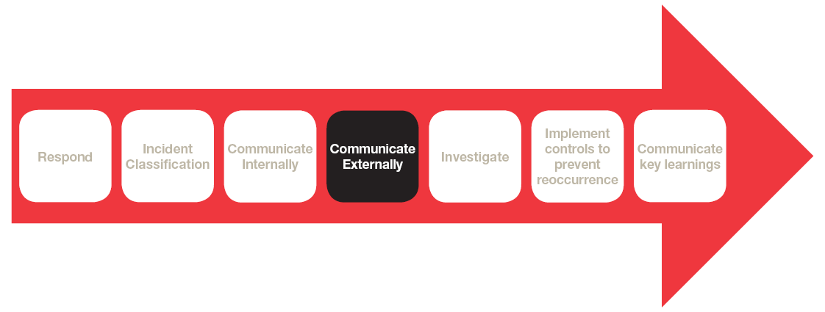
In the event of a Critical Incident any communication to an external party (including contract partners, regulators, media, online or social media) will be conducted by the Critical Incident Team, led by the General Manager (Development Manager in Recreation Sector) and supported by the Communications Team.
The Site Manager will lead communications for any Major or Minor incidents.

3.4.1 Communications to media, online and on social media
External communications of any kind to media, online or on social media should not be conducted by staff members or supervisors under any circumstances.

3.4.2 Communication of the incident to external authorities or regulators
Where any incident constitutes criminal or illegal activity, or meets the legislative requirements to report and notify an external authority or regulator the Site Manager must notify the relevant Area Manager who in turn must notify their General Manger (or Development Manager in Recreation Sector) that the report is being made prior to any notification occurring.
Refer to the External Authorities Notification for how, when and which regulators are required to be notified in specific circumstances.
Support and guidance regarding written notification to external authorities and regulators is also available from Shared Services (RSEQ, People and Culture, the Communications Team, and Disability Services.)
As mentioned in the ‘Respond’ section, immediate communication needs to occur to DHHS when child protective services attend a facility to collect a child and is not the authorised contact for that child.

3.4.3 Communication of the incident with contract partners
Where notification to contract partners for any Critical Incident is required, the CIT supported by the Area Manager, will lead the communication to the contract partner. In some instances, communication may need to occur prior to the CIT being formed. In this instance the General Manager (or Development Manager in Recreation Sector) in conjunction with the Shared Services team will provide advice to the Area Manager on this.
For communication to contract partners for Major or Minor incidents, this is made by the Site Manager and Area Manager as specified in their relevant contract.

3.4.4 Communication with YMCA Australia and other interested YMCA Associations
Contact with other relevant partners, including YMCA Australia and other interested YMCA Associations shall be made by the CEO in accordance with the External Authorities Notification. There is a requirement to notify YMCA Australia of all notifiable Critical Incidents as per the YMCA Australia Critical Incident Policy.

    - Communication to/provision of internal documents to parents
Where notification to the parent/authorised contact of a child for any Critical Incident is required, the Critical Incident Team supported by the Area Manager, will lead the communication to the authorised contact.
For communication to the authorised contact of a child for Major or Minor incidents, this is made by the Site Manager.
An authorised contact of a child must be notified as soon as practicable, but not later than 24 hours after the occurrence, if the child is involved in any incident, injury, trauma or illness whilst under the care of the YMCA.
Where the YMCA has been instructed by police or other authorities to not inform the authorised contact of an incident, notification to the authorised contact is not required.
Once the authorised contact has been notified of an incident, the authorised contact is required to sign the completed incident form relevant for the service as per below;
- For services operating under the Education and Care Services National Regulations 2011 (ELC, Kinder, OSHC and Vacation Care) complete the Children's Programs Child Incident, Injury, Trauma and Illness Record

- For services operating under the Victorian Children’s Services Regulations 2009 (crèche, occasional care and limited hours services) complete the Children's Services Incident/Injury Report Form

  - Investigate
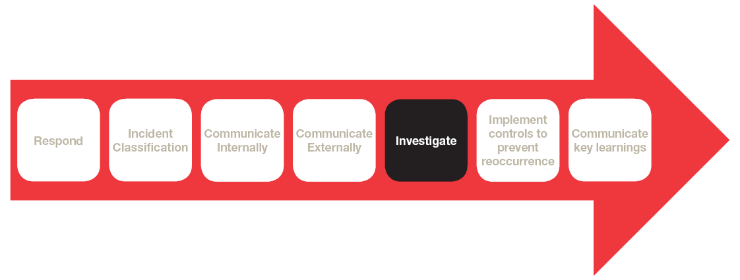
    - Conducting an investigation
The Site Manager is responsible for ensuring that all Major Incidents are investigated and all Minor Incidents are reviewed. The CIT are responsible for investigating all Critical Incidents.
To ensure the investigation is effective, it is essential to involve all relevant people, including any employees involved in the incident and who work in the area, and the relevant member of the management team on site.
Investigations can be conducted in many ways internally including root cause analysis and if required, external investigations can be requested in certain circumstances. The method of incident investigations for Critical Incidents is determined by the CIT or external regulatory authority (where the regulator has requested a specific incident investigation/root cause analysis to be conducted).
All incidents remain open in INX until the investigation is complete and corrective actions have been recorded in INX, actions tab and corrective actions have been implemented and closed out. Below are the key steps to conduct a basic incident investigation:
- Obtain the Facts. Collect all the facts, evidence and information to analyse and determine the cause(s) of the incident.
- Use the Incident reporting tabs in INX or the relevant investigation template to help you ascertain the causes of the incident. There is generally more than one cause as to why an incident has occurred and by gathering detailed information, you can help reduce the impact and likelihood of the incident happening again.
Information must be FACTUAL and provide enough information to paint a complete picture of what has occurred and how the incident transpired. Refrain from including:
- Assumptions;
- Issues identified which did not directly contribute to the incident occurring;
- Personal opinions; or
- Allegations or blame.

    - External investigations
The requirement for an external party to undertake an investigation into an incident may be legislated or documented in contract agreements. External investigation may be requested by the CEO or Executive, the Board, its Sub-Committees or the Critical Incident Team. Should an external investigation be required the investigation outcomes and dissemination of information and assigning actions should be completed and recorded in INX.
    - Legal Professional Privilege
All incidents that are subject to LPP must be investigated and documented at the direction of the legal advisor providing advice in relation to the specific incident. For the avoidance of doubt the matters below do not apply to LPP matters unless specifically referred to.
    - Investigating and Reporting Critical Incidents
All Critical Incidents are to be investigated and reviewed by the CIT. Once reviewed (including legal review when LPP applies), the investigation report can be uploaded to the Critical Incident page on YNet and INX. Corrective actions are to be recorded in INX actions tab. The CIT lead is responsible for ensuring that all Critical Incidents are investigated, with involvement from relevant shared services, employees involved in the incident, management on site and any other relevant parties. Use the relevant Critical Incident investigation template which is listed in the Supporting Documents Section of this procedure.
For all incidents other than Safeguarding Children and Young People (SCYP), complete an incident investigation report using the relevant incident investigation report template within 14 days of the incident occurring.

For all SCYP matters, an Investigation Plan must be completed by the relevant Area Manager and approved by the Executive Officer prior to an Investigation Report being completed. Review the External Authorities Notifications table for required timeframes.

The person conducting the incident investigation must be trained in how to conduct an incident investigation. The incident investigation report should include;

- Factual outline of what happened
- Timeline of events
- What response was undertaken by the team at the time of the incident
- How the incident was investigated (i.e. method used – Root Cause Analysis/iCAM etc.)
- The root cause(s) which directly contributed to the incident occurring
- What corrective actions are being implemented to prevent reoccurrence of the incident

In some circumstances, the incident investigation report is to be provided to external parties including contract partners or a third party. In this instance, the report should be reviewed and quality assured by relevant General Manager (or Development Manager in Recreation Sector) before providing the report externally.

Where LPP has been applied to an incident, the report should be provided to legal prior to release.

Critical Incidents require specific reporting to the board, OLT and Critical Incident team. Follow the Critical Incident Checklist and Critical Incident page on YNet to ensure reporting on the incident’s progress within the required timeframes.

    - Investigating and Reporting Major Incidents
All Major Incidents are to be investigated within 14 days, and corrective actions recorded in INX via the Investigations Tabs. Follow the INX tabs from left to right and implement appropriate corrective actions to prevent reoccurrence.
    - Reviewing and Reporting Minor Incidents
All Minor Incidents should be reported, reviewed and corrective actions recorded in the INX actions tab.
Complete your incident review within 30 days of the incident occurring by following the INX tabs from left to right and implement appropriate corrective actions to prevent reoccurrence.

  - Implement Controls to Prevent Reoccurrence
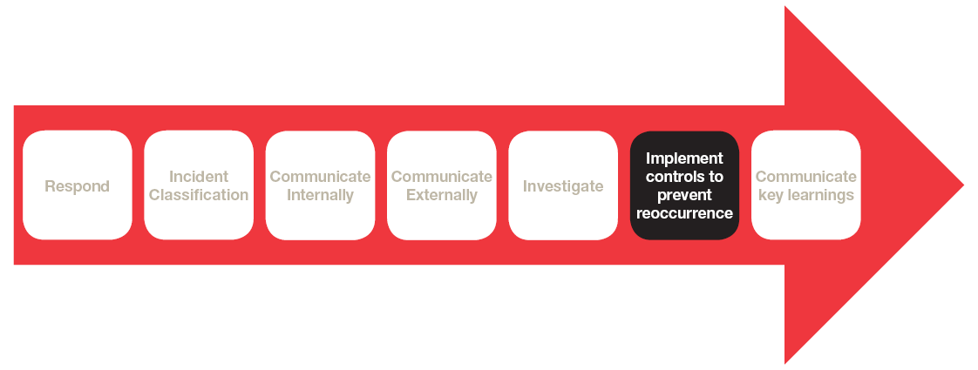
3.6.1 Identifying Controls and Assigning Actions
After an incident has been investigated or reviewed, the identified controls should be assigned as actions to the relevant people, as part of the incident in INX. As well as a responsible person assigned, each control should have a due date set.
For safety related controls, following the Hierarchy of Control (from top down) will assist in determining the most effective controls to implement:
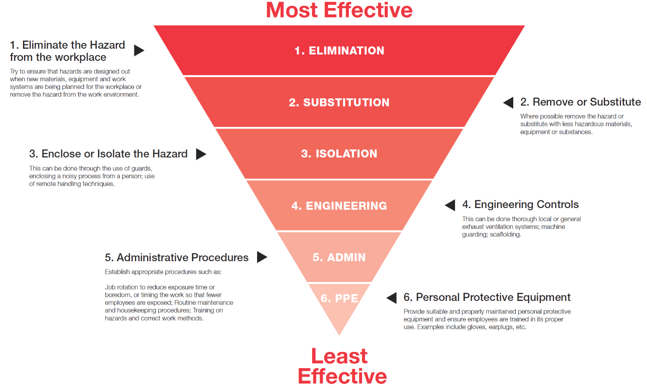

3.6.2 Closing out the Incident in INX
- Ensure all corrective actions have been implemented to prevent reoccurrence of the incident.
- Once corrective actions have been implemented, close out all actions allocated in INX.
- Upload all investigation paperwork and related documentation in INX.
- Once the above tasks have been completed, close out the incident in INX via the Event Close Out tab.

  - Communicate Key Learnings
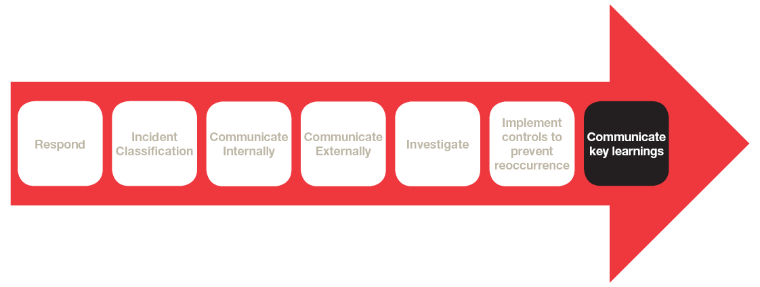
    - Local Changes to only one site
Where the incident and investigation outcomes relate only to the one site, details of communication of the changes must be documented (minutes, training attendance) and recorded in the Incident Management System (INX).

Any changes to standard operating procedures or changes to risk assessments are to be fully communicated to relevant managers across the organisation and all employees who work in the area affected by the changes.

    - Wider impact to two or more sites, cross sectors and the organisation

Where identified incident causations or corrective actions have wider implications, relevant organisational management systems, processes, practices or activities may require review.

These implications must be communicated to the relevant sites, sectors and/or organisation via communication methods such as an organisational alert or wider communication to the organisation.

- LEGISLATIVE AND INDUSTRY REQUIREMENTS

- OHS Act 2004 & Regulations 2017 (Vic)
- WHS Act & Regulations (South Australia, ACT, NSW, QLD)
- Environmental Protection Act 1970 (Vic)
- Environmental Protection Act 1994 (QLD)
Environmental Protection Act 1993 (South Australia)
- Environmental Protection Act 1997 (ACT)
Environmental Protection Act 1997 (NSW)
- Privacy Act 1988 (Cth)
- Privacy Amendment (Notifiable Data Breaches) Act 2017
- Water Act 1989 (VIC)
- Working with Children Act 2005
- Working with Children Regulations 2006
- Education and Care Services National Act 2010
- Education and Care Services National Regulations 2011
- Child Employment Act 2003
- Children’s Services Act 1996
- Children's Services Regulations 2009
- Serious Sex Offenders Monitoring Act 2005
- Sex Offenders Registration Act 2004
- Disability Act 2006
- Charter of Human Rights and Responsibilities Act 2006
- Occupational Health and Safety Act 2004
- United Nation Convention on the rights of the child
- Children, Youth and Families Act 2005
- Commission for Children and Young People Act 2012
- Victorian Crimes Act 1958
- Child Safety and Wellbeing Act 2005
- NDIS Quality and Safeguarding Framework
- Public Health and Wellbeing Regulations 2009

- DEFINITIONS

Acronym | Explanation
CCYP | Commissioner of Children and Young People
CIT | Critical Incident Team
DET | Department of Education and Training
DHHS | Department of Health and Human Services
EPA | Environmental Protection Authority
INX | YMCA and associated entities Incident Management System
LPP | Legal Professional Privilege
OAIC | Office of the Australian Information Commissioner
SCYP | Safeguarding Children and Young People
WorkSafe | WorkSafe Authority for the State or Territory operating from

Phrase | Definition
Site Manager | The YMCA person responsible for a specific centre, camp, service, office and programs
Incident | Incident includes, all incidents, injuries and near misses
Legal Professional Privilege | Protection of confidential communications between a lawyer and their client made for the dominant purpose of:  - Seeking or giving legal advice or professional legal assistance; or  - Use, or obtaining material for use, in legal proceedings that had commenced, or were reasonably anticipated, at the time of the relevant communication.
Near Miss | An event where an actual incident or injury was not sustained but had the potential to occur
Site | Includes all YMCA and associated entities centres, camps, service, office and programs
Site Preservation | In the event of a notifiable incident, the site may need to be preserved for external investigators
Staff | Includes all payed staff and volunteers within YMCA Victoria

- ROLES AND RESPONSIBILITIES
Outline key department and/or organisation roles and identify specific responsibilities for each department/role. Any recommended changes or amendments need to be cross checked to the YMCA Victoria Delegations of Authority Map
Department/Role | Responsibility
Operations
YMCA and associated entities CEO | Reporting all Critical Incidents to the:  - CEO of YMCA Australia;  - Chair of the YMCA Board; and  - Chair of the Risk Sub Committee
Executive Officers | Provide support and resources to members of a Critical Incident Team including;  - Provide resources required for priority matters  - Support CIT strategy for control and recovery
General Manager or Development Manager (in Recreation Sector) | Lead the Critical Incident Team including;  - Be the initial point of call for the Critical Incident Team  - Lead the Critical Incident Team  - Chair CIT meetings  - Primary decision maker.  - Select, mobilise and provide direction and support to the CIT.  - Maintain Critical Incident Site, Legal Advice and Critical Incident Log on Y-NET (or elect delegate to do this).  - Provide support and direction to the CIT  - Maintain oversight throughout the process.  - Manage incident, investigation and related practices in line with YMCA and associated entities Incident Management Procedure  - Determine strategy for control and recovery.  - Manage any legal, financial and insurance related matters.  - Monitor and ensure completion of corrective actions  - Responsible for critical incident team closure
Area Manager | Provide support, guidance and resources to operational teams;  - In relation to compliance with this procedure  - In relation to compliance with external reporting to regulators/authorities and contract partners  - Maintain oversight throughout the process  - Manage incident, investigation and related practices in line with YMCA and associated entities Incident Management Procedure
Site Manager | Provide response, guidance and support to site team;  - In relation to compliance with this procedure  - In relation to compliance with external reporting to regulators/authorities and contract partners  - Maintain oversight throughout the process  - Manage incident, investigation and related practices in line with YMCA and associated entities Incident Management Procedure
Supervisor | Know and understand this procedure including;  - How to respond, escalate and report incidents at YMCA and associated entities  - Provide support and guidance to staff in response to an incident at YMCA and associated entities
Staff | Know and understand this procedure including;  - How to respond, escalate and report incidents at YMCA and associated entities
Shared Services
Communications | - Seek legal advice as required  - Monitor news for emergency service and public safety announcements.  - Coordinate all internal and external communication through application of the Communications Plan  - Manage all ongoing communication requirements
RSEQ | - Provide immediate support and advice as required  - Seek legal advice as required  - Lead Safety incident investigation as required  - Lead Environment incident investigation as required
SCYP | - Provide immediate support and advice as required  - Seek legal advice as required  - Lead SCYP incident investigation as required
People and Culture | - Provide immediate support and advice as required  - Seek legal advice as required  - Lead People and Culture incident investigation as required
Finance | - Provide immediate support and advice as required  - Seek legal advice as required  - Lead Financial incident investigation as required
Business Systems | - Provide immediate support and advice as required  - Seek legal advice as required  - Lead Business Systems incident investigation as required

- QUALITY ASSURANCE ACTIVITIES

(LINKS TO ASSURANCE PLAN AND MASTER RECORD REGISTER)
This procedure will be monitored and reviewed for effectiveness through the application of the RSEQ assurance plan, developed in accordance with the YMCA and associated entities Assurance Procedure.

- SUPPORTING DOCUMENTS

(LINKS TO PROCEDURES AND/OR SUPPORTING DOCUMENTS)
- Incident Management Response (Action Lanes)
- External Authorities Notification
- First Aid Report Form – Minor Injury
- First Aid Report Form – Major/Critical Injury
- Critical Incident Board Summary Report
- Critical Investigation Team Checklist
- Business Systems Investigation Report Template
- HSE Investigation Report Template
- HR Investigation Report Template
- Investigation Plan for Reportable Conduct Scheme
- SCYP Investigation Template
- Incident Report Form Template
- Interview Record
- YMCA Australia Critical Incident policy
- Children's Programs Child Incident, Injury, Trauma and Illness Record
- Children's Services Incident/Injury Report Form
- Letter for request of form

- APPROVAL AND REVIEW

Meeting Approved: YMCA Victoria Board
Meeting Approved Date: 05/03/2019
Procedure Effective Date: 05/03/2019
Procedure Review Date: 05/03/2021
Procedure Owner: General Manager RSEQ
Contact Details: nicole.rudden@ymca.org.au

Amendments
Version | Date | Author | Change Description
V1 | 2016 | Erin Smith | Development of Incident Management Procedure
V2 | 24/03/2017 | Olivia Farrar | Position titles amended to reflect organisational structure
V3 | 20/11/2018 | Michelle Page,  Hannah Parkin,  Constance Thomas | Updated Procedure including feedback from all areas of organisation (including operational teams across all sectors and executive level)
V4 | 06/02/2019 | Dan Coathup | Updated with feedback from RSEQ team, legal and OLT.  Endorsed by Risk Sub Committee

